**Signs With Smart Connectivity For Better Road Safety**

**TEAM ID - PNT2022TMID21659**

**CREATE NODE RED**

**NODE RED**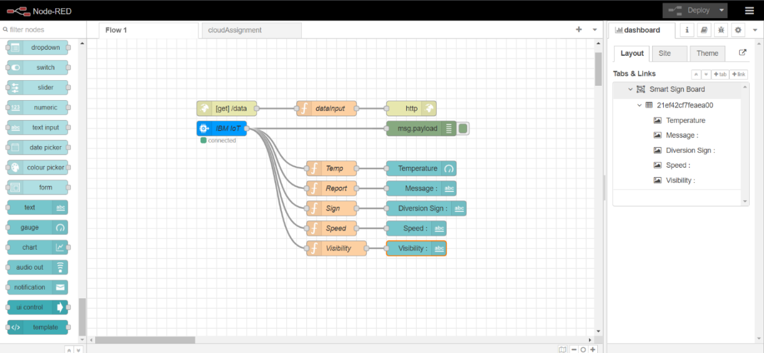

**APP UI**

